Edward Liandi (2702368154), L2CC

28-2-2024, Tuesday

Data Structures Week 3: Activities

A – The algorithm is O($n^{2}$). That is because when n = 100, j is printed 100 times for every number of i until I is just lesser than 100 times. This results in 10 000 prints in total.

B – The algorithm is O(2n). That is because when n = 100, j is printed 2 times for every number of I until I is just lesser than 100 times. This results in 200 prints in total.

C – The algorithm is lesser than O($n^{2}$). That is because when n = 100, j is printed decreasingly for every number of I until I is just lesser than 100 times. As j will stop for each i when the values are the same as the I it is a part of, the results are less than 10 000 prints.

D – The algorithm is O(n)-1. I do not exactly understand the output, but the result is 99 prints of j = 0 for each I =1-99. In my opinion, the j should not just be consistently 0 as when j % I == 0, the j should have possess a certain value != 0. However, j is always 0, so I do not comprehend why.

A – The contents of anArray after the execution of each loop is {4, 5, 6, 7}.

B – The contents of anArray after the execution of each loop is {6, 5, 4}.

A – O(n)- T(n)

B – N^3



N

N^2

N^3

2^n



From <https://www.baeldung.com/cs/adt>

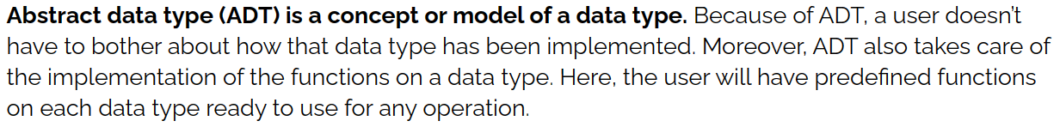



From <https://www.geeksforgeeks.org/difference-between-list-and-arraylist-in-java/>

import java.util.ArrayList;  
import java.util.List;  
  
public class ArrayListExercise {  
 public static void main(String[] args) {  
 List<Integer> some = new ArrayList<>();  
 int[] nums = {12, 25, 34, 46};  
 for (int numsNext : nums) {  
 some.add(numsNext);  
 System.*out*.println(some);  
 }  
 some.remove(1);  
 System.*out*.println(some);  
 }  
}